**Software Requirements Specification**

For

**Online Calender**

Prepared by:

Javatraining2014

## Introduction

***Purpose***

The purpose of this document is to present a detailed description of the Online Calender application. It will explain the purpose and features of the application, the interfaces of the application, what the user can do. This document is intended for both the user and the admin of the application.

***Scope***

Online Calender is a calender application through which the users can host the events and alerts the team members by providing remainders.More specifically, This applcation is designed to manage and remaindes the events via E-Mail on the particular day.

**Functional Requirements**

**Modules**

1. Admin Module
2. User Module

***Admin module:***

The Admin module have the following functionalities

* Add Team – Admin can add a new team.
* Update Team – Admin can update the details of existing team.
* View Calender – Admin can view the particular team calender.

***User Module:***

The User module have the following functionalities

* Manage Events – The user can manage the events like creating events and editing the existing events.
* View Calender – The user can only view his team calender.
* Profile – The user can view and edit his profile.

**UI Requirements**

1.Login Screen:

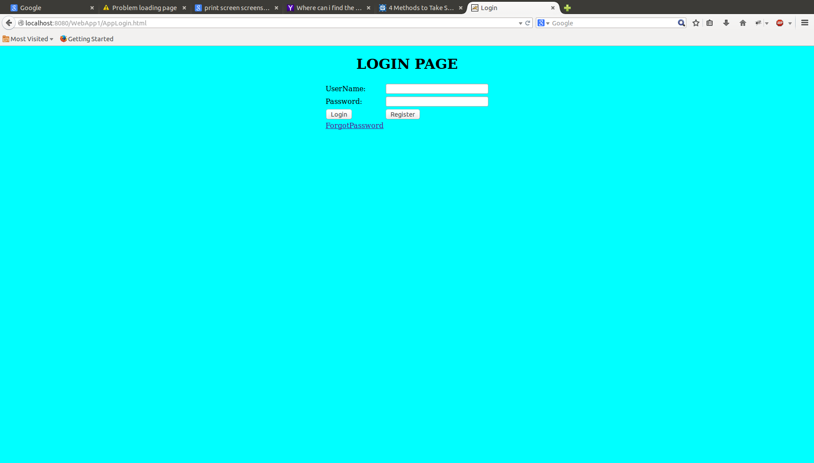

* User need to provide the valid credentials to enter into the application.
* On clicking register button it should navigate to register page.

2.Registration Screen:

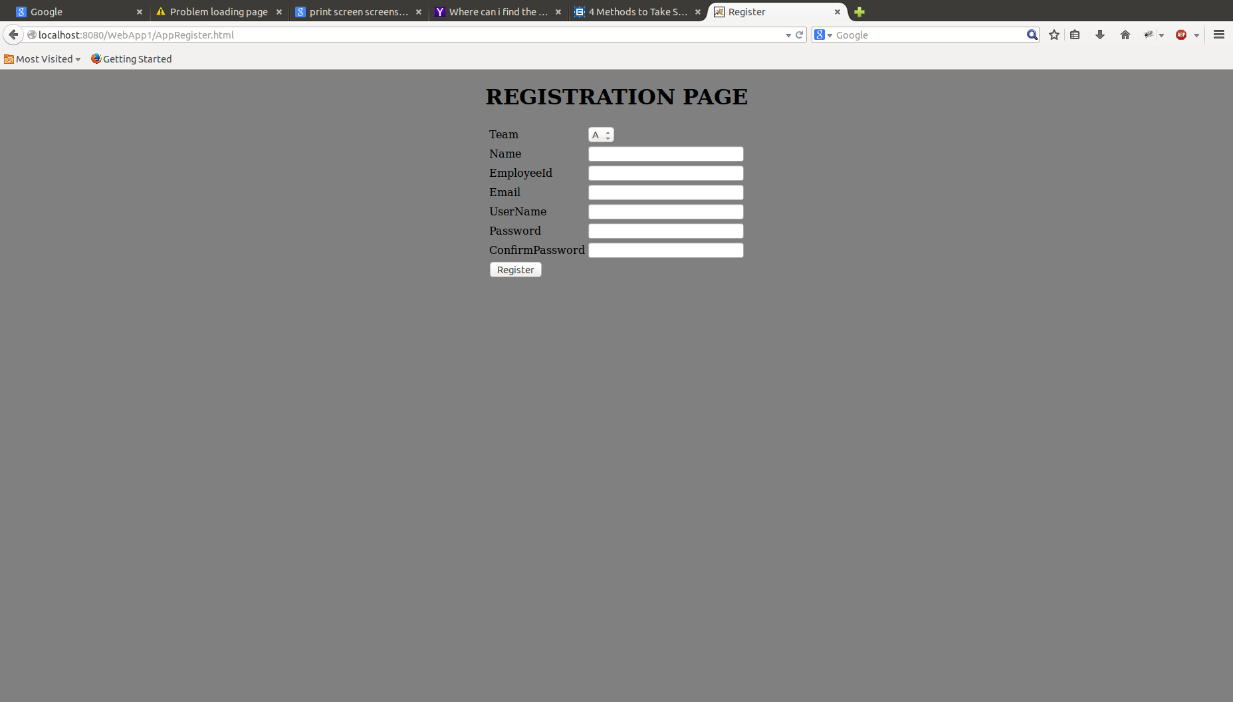

* Here the user need to provide the above details to register.
* When he clicks on register button it should navigate to login page.

3.Admin Page:

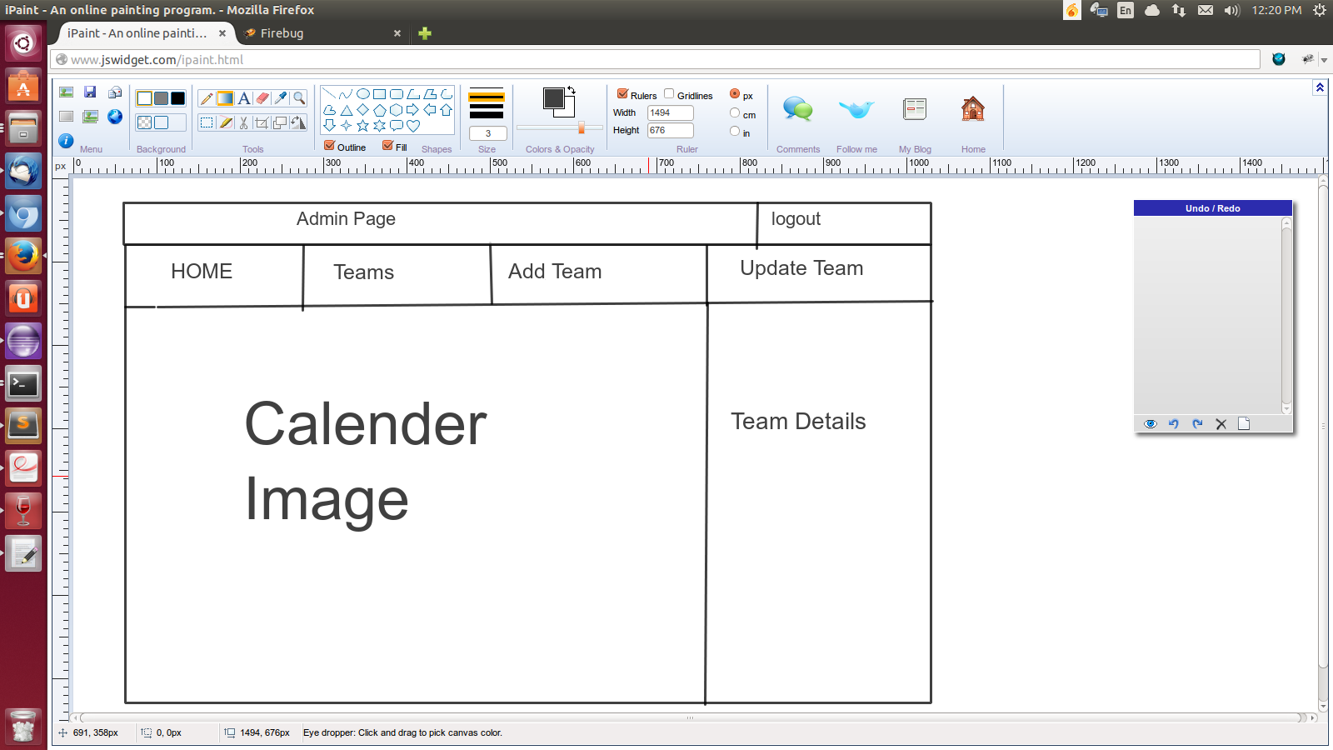

* When admin logged in successfully he should navigate to admin page.
* The admin can perform operations like add team and update the team.

4.User Page:

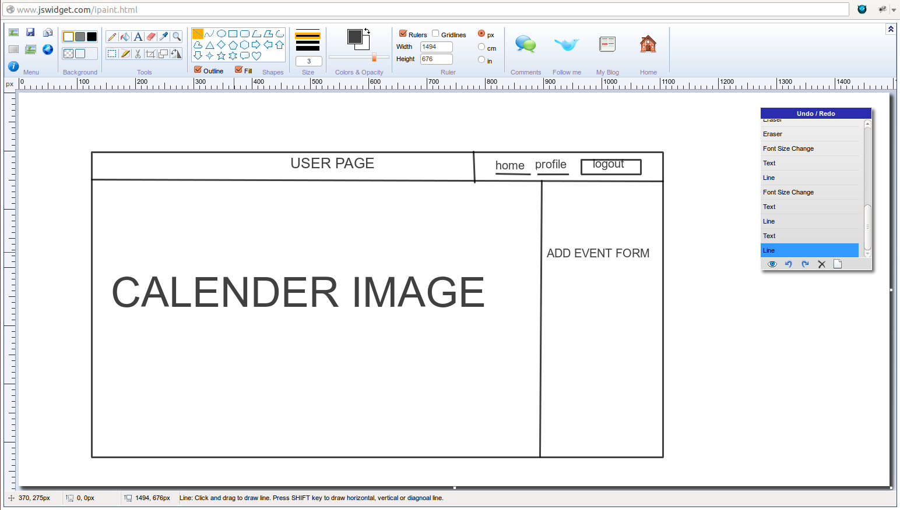

* When user logged in successfully he should navigate to user page.
* Here the user can view the events, add the new event and update.
* Here user can update his profile.